**RUBY** 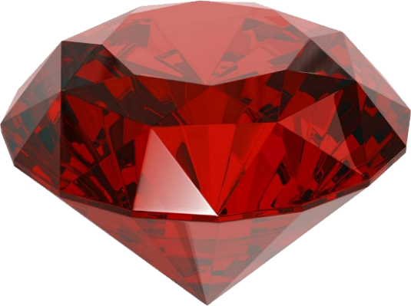

It is a red stone that rates 9 on the Mohs hardness scale. The Ruby crystal is a variety of corundum (aluminum oxide) and this is what gives the stone its red coloring. It is part of the hexagonal crystal system and is an expensive precious stone with a higher price for the quality of cut and carat.

It has been associated with improved energy and concentration. Ruby is thought to be protective of home, possessions and family. Ruby is said to stimulate heart chakra and bring spiritual wisdom while shielding against psychic attacks.

ruby gemstones to the best ruby because they are more intense red in color and have a higher level of fluorescence than other rubies. Burmese rubies are among the most desirable colors of ruby due to their deep, intense pigeon blood-red color.

1.  Ruby is thought to be protective of home, possessions and family. Ruby is said to stimulate heart chakra and bring spiritual wisdom while shielding against psychic attacks.

2. rubies were rubbed on the skin to promote vitality and youth. Ruby is said to promote overall wellness in these areas and inspire better health.

3.  Moreover, the ruby stone is said to sharpen mental focus, stimulate ambition and motivation, and inspire leadership qualities.